SCOTTISH EPISCOPAL CHURCH
Diocese of Brechin
House for Duty Priest, Church of the Holy Rood
Maule Street Carnoustie, Angus
(Charity No. SC009480)

Applications are invited for the post of part-time Priest in Charge, with a negotiable remuneration package including house (if required).
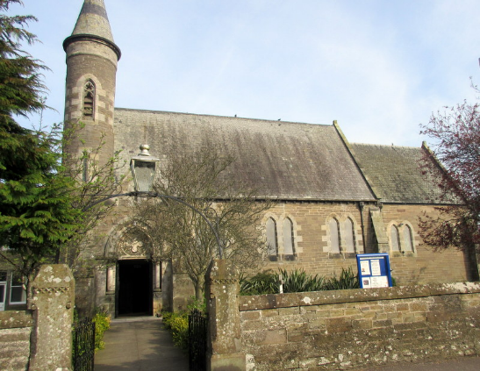
Carnoustie is a small town on the East Coast of Scotland
11 miles from Dundee and 5 miles from Arbroath, with good transport links to the rest of Scotland. It is famous for golf and will host the British Open in 2018. The church’s roots can be traced back to 1836. The church has been recently refurbished with new central heating and new, comfortable chairs. We are one of the few churches in the diocese with an excellent choir and a congregation who are all actively involved in church and community life.

The Vestry and congregation are looking for a priest:
- to work Sundays and two days each week (negotiable)
- to provide missionary and pastoral leadership, support and nurture to the congregation
- to develop new outreach initiatives
- to encourage and develop the role of laity within church life
- to continue our links with the ecumenical Ministers’ Council and the seven other churches in the town

The Vestry and congregation would welcome and enthusiastically support our new priest to the church family and the local community. The home we offer, if required, is a large family house situated in the grounds of the church. It has been well maintained and is in good order. Alternatively, a housing allowance would be available for a priest living in his/her own accommodation.

Contact Mrs Sharon Louden at the Brechin Diocesan Centre for further information and application form (hard copy).
Telephone number 01382 459569
Email: office@brechin.anglican.org

CLOSING DATE FOR APPLICATIONS: THURSDAY 5th OCTOBER 2017

